Create a S3 bucket, with no public access and upload files to the bucket & view the logs using cloudwatch for the uploaded files

Create a s3 bucket

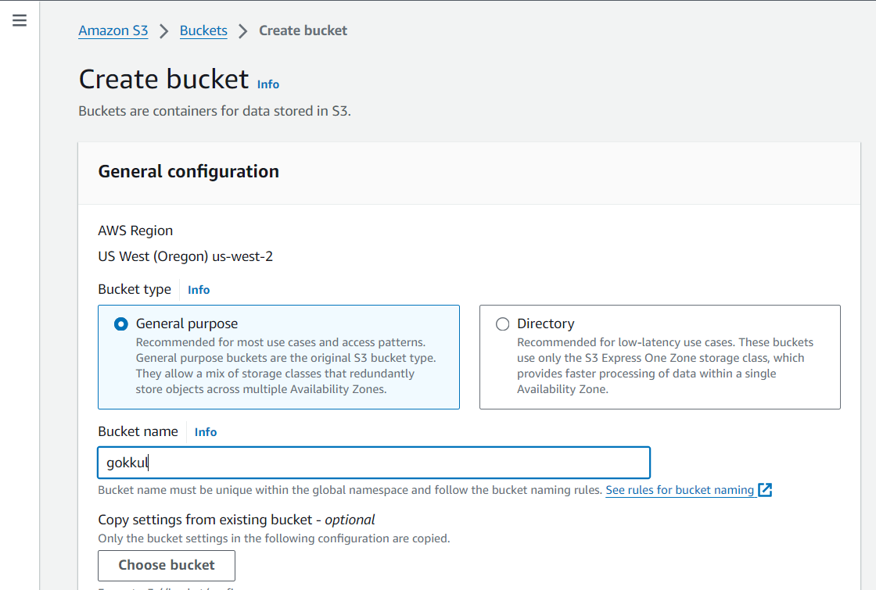

No block acces

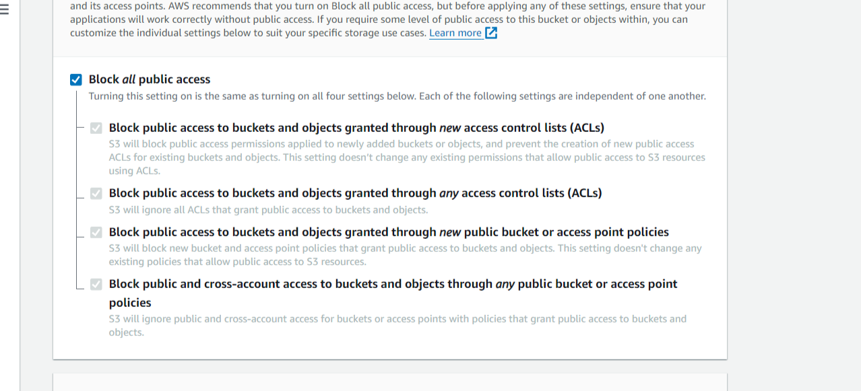

Create cloud trail account then join the S3 bucket 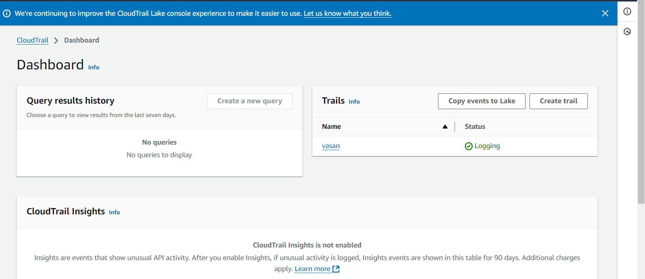

Finally go to that account see the s3 file account in cloud trail

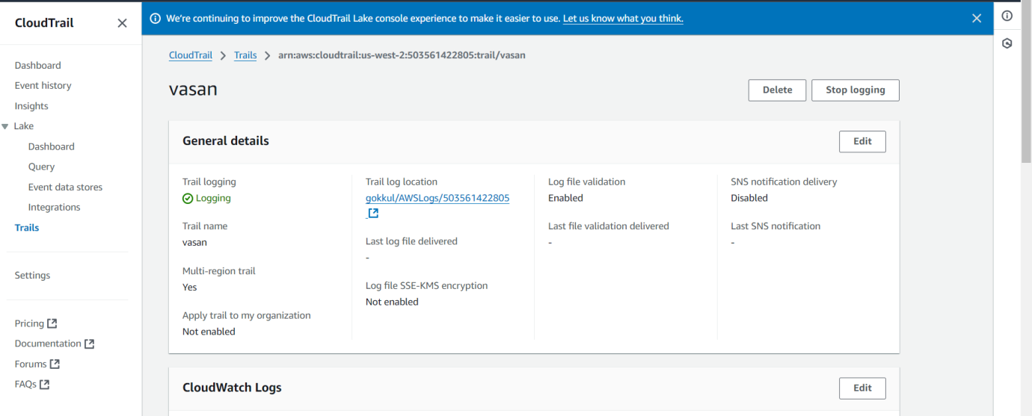

Launch two ec2-instances and connect it to a application load balancer, where the output traffic from the server must be an load balancer IP address

Launch two ec2-instances

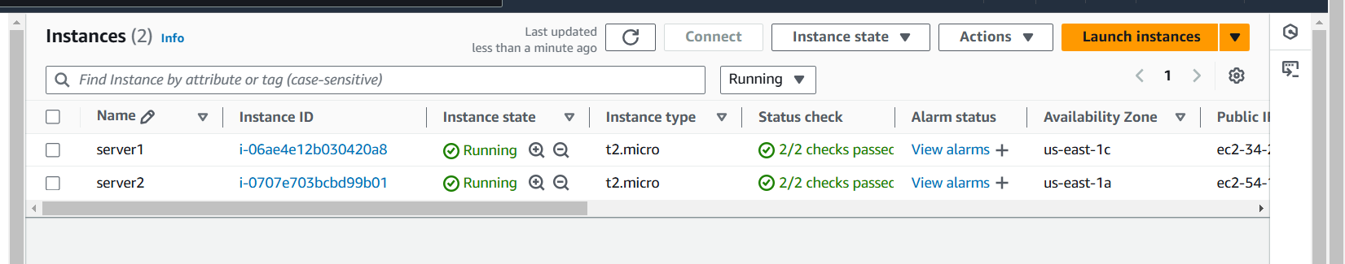

Create a target group for the two instances

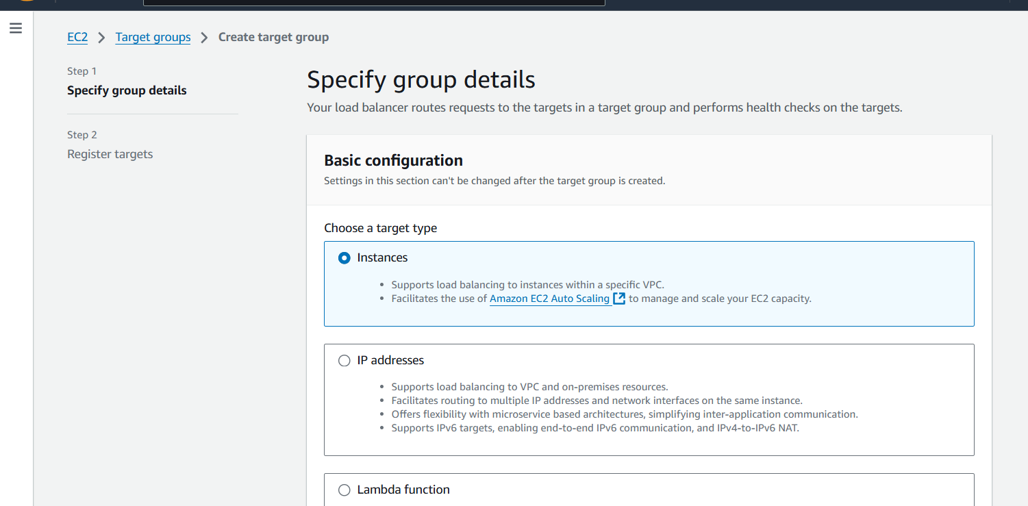

Set path of file

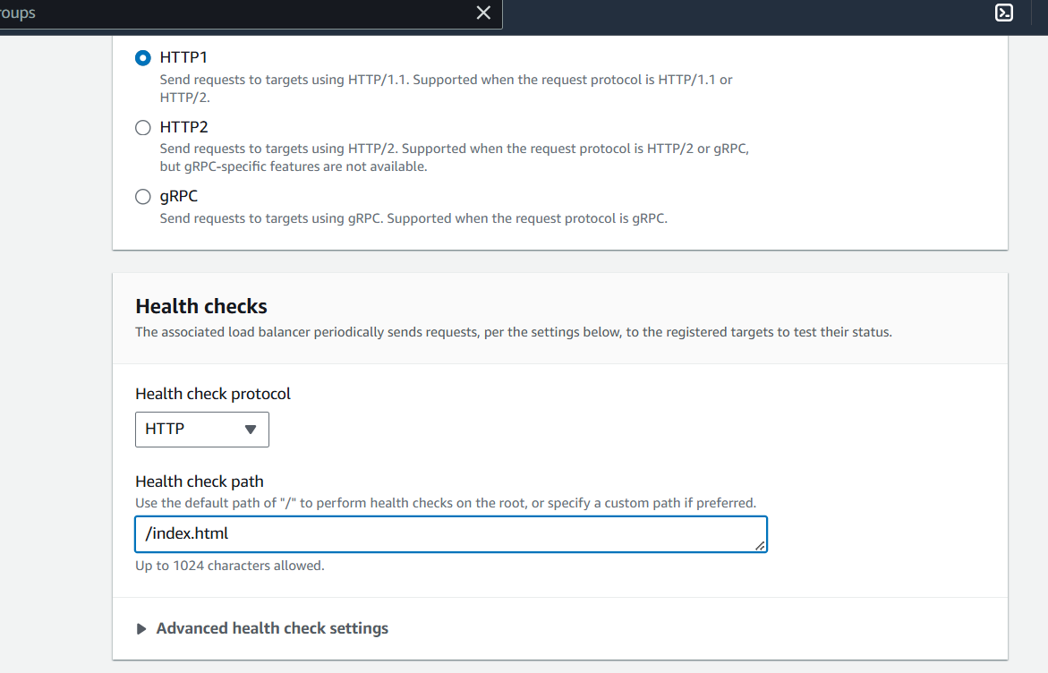

Finally created a target group

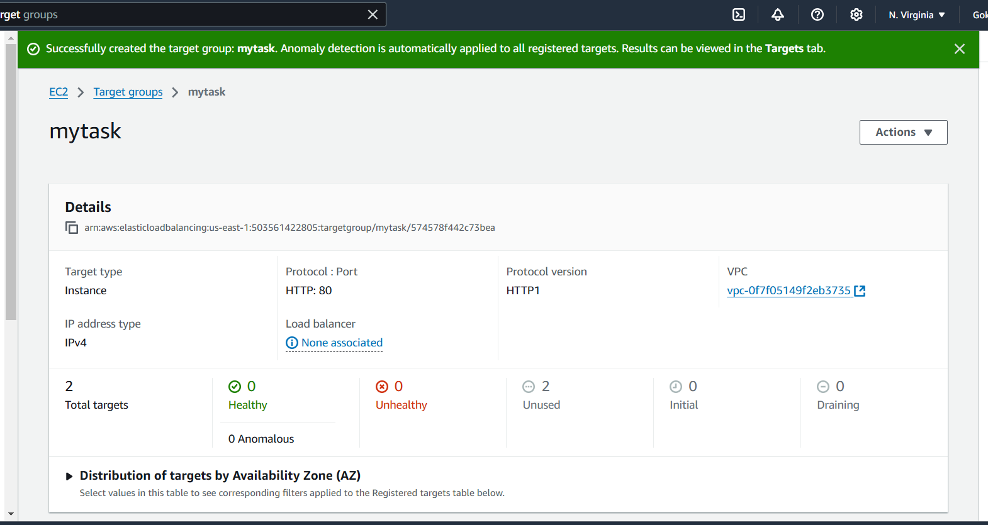

Now create a load balancer

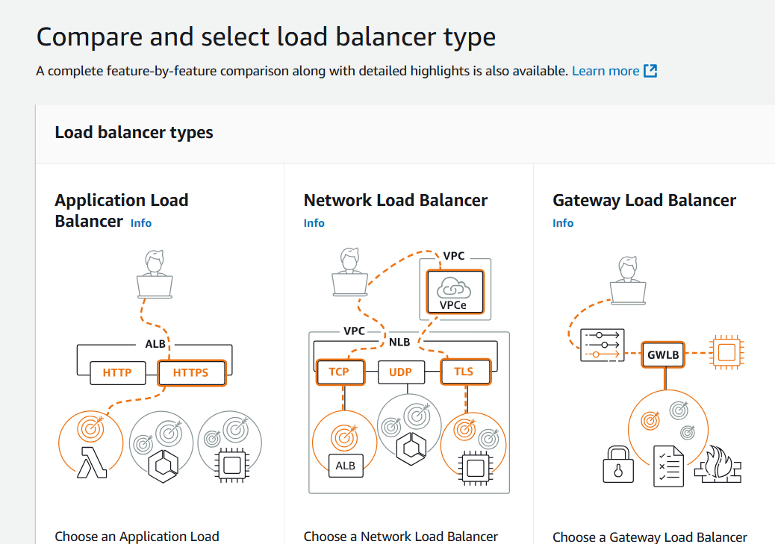

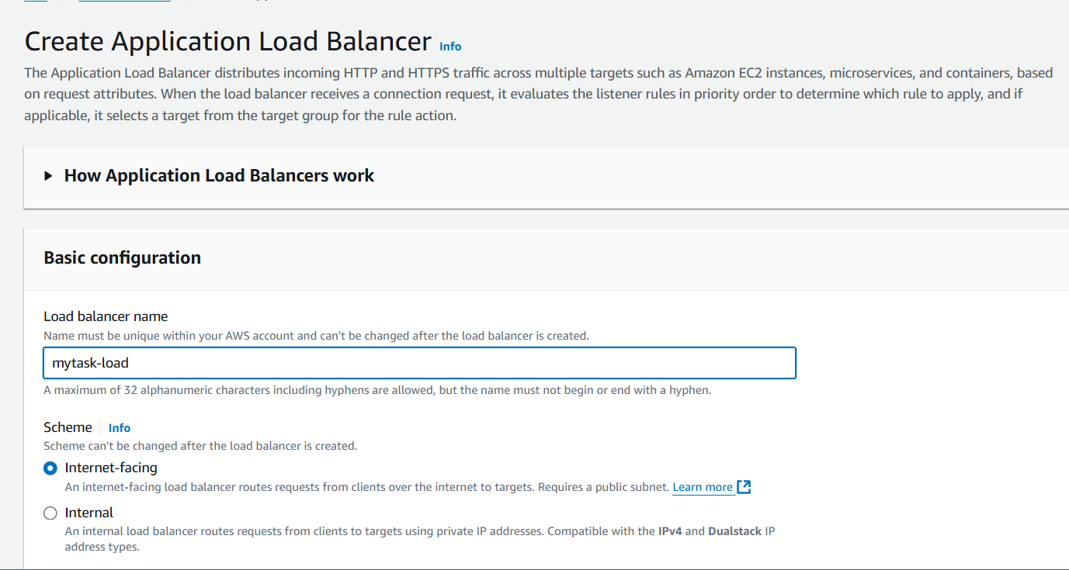

An create a security group for load balancer

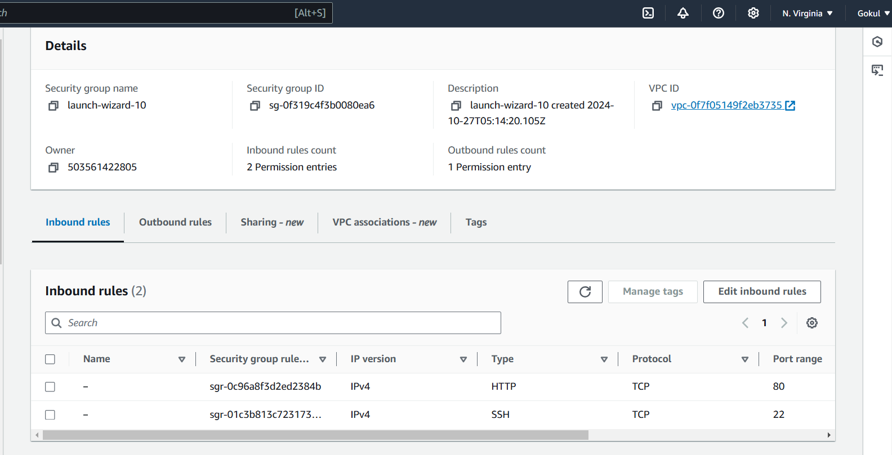

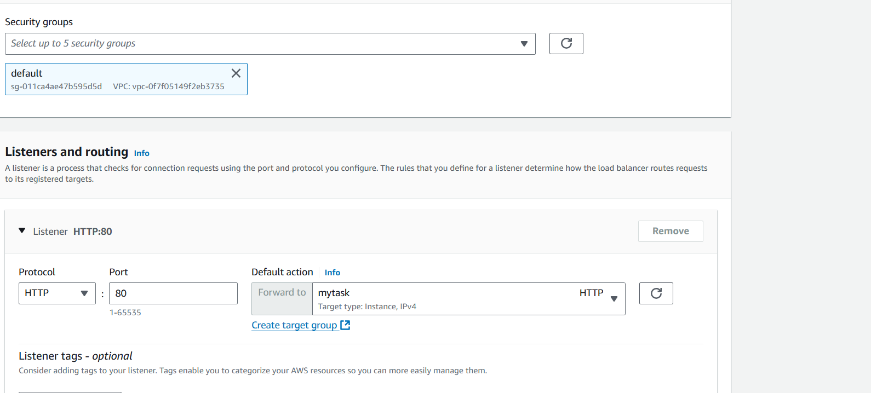

Finally created a load balancer

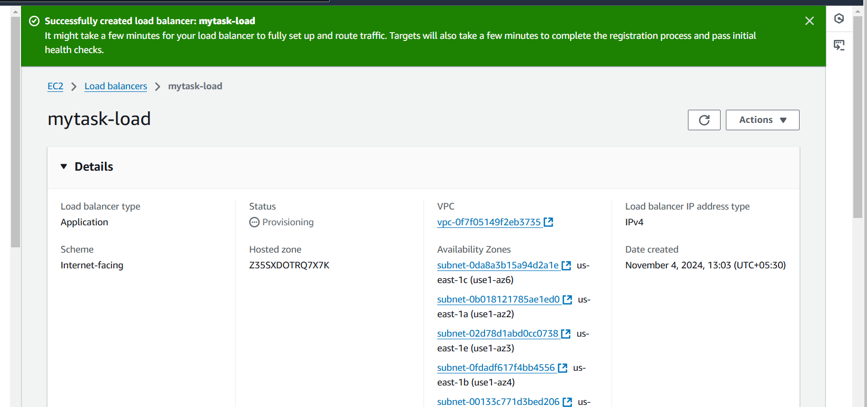

Take a DNS name to website

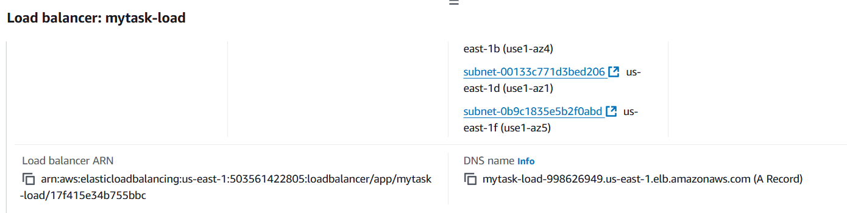

First server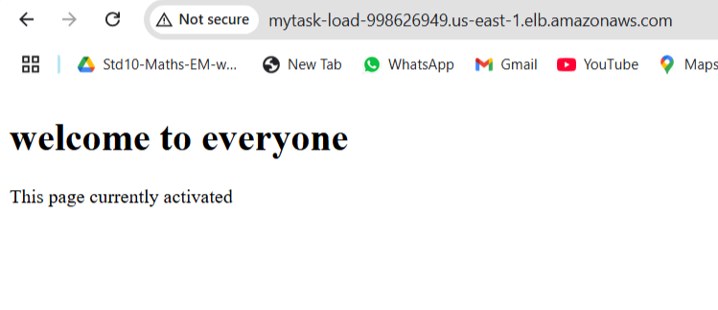

After refresh second server

